Physics 20 Lesson 30 Waves in Two Dimensions

Refer to pages 392 to 415 in Pearson for a discussion of the properties of waves.

Two-dimensional waves share many of the properties of one-dimensional waves, but there are differences in how the properties manifest themselves. In addition, there are several new properties like refraction and diffraction that we shall discuss.

Waves in two dimensions, like ripples on water, are worth studying since we can readily observe all kinds of different wave phenomena by generating ripples. A common ripple pattern is straight wave fronts moving in a given direction. The diagrams below represent two-dimensional waves as seen from above.

crests

troughs

wave front diagram

wave ray diagram

●

The lines on the *wave front* diagram represent the crests of the waves and the arrow indicates the direction of its motion. The *wave ray* diagram is equivalent to the wave front diagram; it represents a set of wave fronts moving in a given direction.

# Reflection

When a wave strikes a solid boundary, it will be reflected by the boundary. This is similar to a basketball bouncing off of a floor.

Incident wave

Reflected wave

reflecting surface

i

r

**normal**

i = r

Incident wave

Reflected wave

The Law of Reflection is: **The angle of incidence equals the angle of reflection**. (i = r)

Note that the angles are not measured from the surface of the boundary; they are measured from an imaginary line called the **normal line** which is perpendicular to the boundary. The reason we use the normal line is because it avoids confusion when the boundary is curved rather than straight. Check out the video clip called P20 L30 Reflection of Waves on D2L.

A wave is incident on boundary A and reflects to boundary B. What is the angle of reflection at boundary B?

The solution to this problem requires (a) using the law of reflection and (b) that the sum of the angles of a triangle is 180o.

2. 90 – 50 = 40

50o

B

A

110o

solution

A

B

3. 180 – 110 – 40 = 30

50o

110o

1. law of reflection

= 50o

4. 30o (law of reflection)

5. 60o (90 – 30 = 60)

The angle of reflection from B is 60o.

# Refraction

Waves travelling in a consistent medium will have a constant frequency, wavelength and speed. However, if the wave enters a region where the medium changes − air to water or deep-water to shallow-water − the speed and wavelength of the wave will change while the frequency remains unchanged. The change in speed and wavelength is due, if you recall from the previous lesson, to the fact that they depend on the medium. However, the frequency depends on the source of the wave and not the medium it is travelling through. Let us derive the relationship between the speed and wavelength of the **incident** and **refracted** waves.

Recall that speed and wavelength are related via ; hence

 

rearranging the equations gives us

 

and since f1 = f2



rearranging we get



Using water waves as our example, what happens when a wave moves from a high-speed area to a low-speed area? As waves pass from a deep-water area to a shallow-water area they slow down and the wavelength decreases.

low

high

High speed

Low speed

If the wave enters a different region at an angle the wave will bend depending on whether it speeds up or slows down.

slow

fast

fast

slow

fast to slow

slow to fast

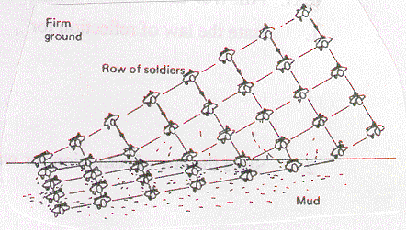

Consider the following analogy. A platoon of soldiers march in formation across firm ground until they march, at an angle, into some mud. Their speed in the mud is slower; therefore the lines of soldiers will bend due to the change in direction caused by the change in speed. In addition, notice that the distance between the rows of soldiers (i.e. wavelength) becomes shorter in the mud area.

An easier way to draw and visualise refraction is to use wave ray diagrams.

normal

Incident wave

normal

Refracted wave

r

i

r

i

Refracted wave

slow

slow

fast

fast

Incident wave

Thus, a wave bends *toward* the normal when it *slows down* (i > r) and the wave bends *away* from the normal when it *speeds up* (i < r). In any case, the side with the greater angle has the faster wave speed. Check out the video clip called P20 L30 Refraction of Waves on D2L.

Note: The angle of incidence (i) and the angle of refraction (r) are always measured from the **normal**.

In 1621, Willebrord Snell, a Dutch mathematician, determined the relationship between i, r, vi , i, vr , r. These relationships are referred to as **Snell’s law** or the **Law of Refraction**. We will now derive Snell’s law. The diagram represents a wave travelling from a fast medium into a slow medium.

 2

 1

2, v2, f2

1, v1, f1

    2

 1

ΔABC where ∠C = 90o

C

B

1

2

A

ΔABD where ∠D = 90o

D

From ΔABC we get  and from ΔABD we get 

Dividing the equations we get 

Noting that BC = 1 and AD = 2 we get 

Using the previously derived equation  from above we get 

Snell’s Law (i.e. **The Law of Refraction**) is:



and we can use any pairing that we desire.

A water wave travelling in deep water at 15.0 m/s enters a shallow region with an angle of incidence of 30o. If the angle of refraction is 22o, what is the speed of the wave in the shallow region?



30o

deep

shallow

22o

v1=15.0 m/s

v2 = **11.2 m/s**

A wave travels from a region with a speed of 45 m/s into a region with a speed of 60 m/s. If the wavelength of the wave is 1.5 m in the slow region, what is the wavelength in the fast region?



2 = **2.0 m**

# Diffraction

In the diagrams to the right we see what happens when waves meet different kinds of obstacles. In diagram (a) when water waves pass through blades of grass, the waves reform around the grass. Similarly, for a stick in the water, the waves reform around the stick. In both cases the waves reform as though the obstacles were never there. For larger objects like a log floating in water (c) and (d) the waves bend around as shown.

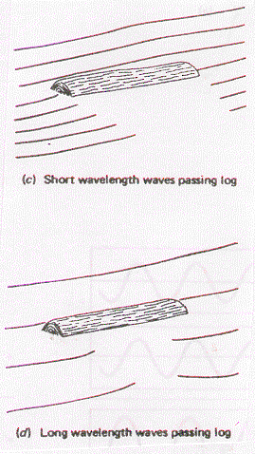

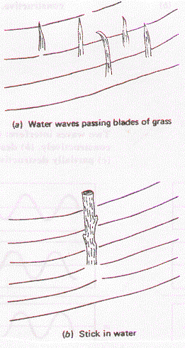

The apparent bending and spreading of waves around corners, around obstacles or through openings is known as **diffraction**.

Christian Huygens, a contemporary and rival of Newton, developed a principle to 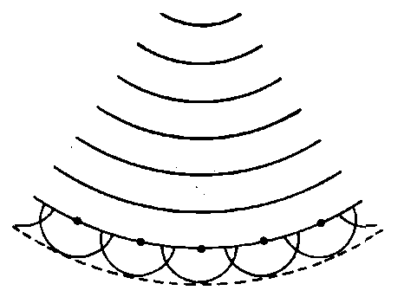explain diffraction and other wave phenomena. Huygens’ principle states: **Every point on a wave front may be considered to behave as a point source for new spherical waves generated in the direction of the wave’s motion**. This is illustrated in the diagram to the right where waves created by a stone thrown into water radiate outward.

In the case of an obstacle, the wave front “bends” around the edges of the obstacle by sending out new wave spherical fronts in circles around the edges of the obstacle. In the diagrams below, notice how the waves diffract from the edges of a corner or an opening to form new wave fronts. This is further evidence for Huygens’ principle.

Check out the video clip called P20 L30 Diffraction of Waves and P20 L30 Diffraction through a slit on D2L.

# Interference

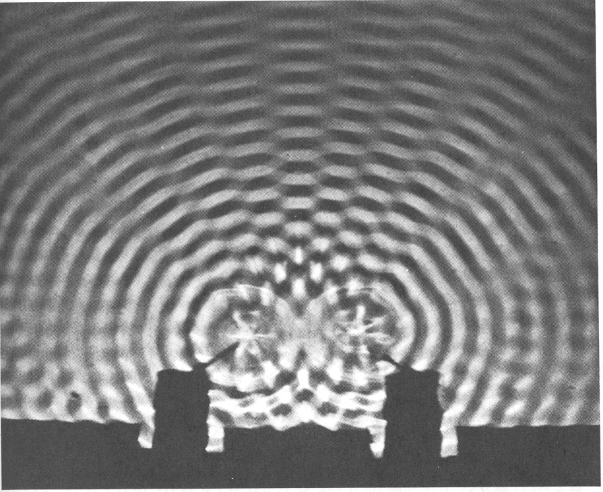

antinodes

nodes

As we saw with one-dimensional waves, when two waves meet they interfere with each other in an additive fashion. The waves combine either constructively or destructively depending on the situation. For two-dimensional waves consider the situation where two sets of waves are being generated at the same time and in the same phase a distance (d) from each other. When crests meet crests and troughs meet troughs, **constructive interference** occurs and these are called **antinodes** or **maxima**. When crests meet troughs, complete **destructive interference** occurs and these are called **nodes** or **minima**. Notice the pattern of antinodes with nodes in between them. (Refer to pages 425 to 428 in Pearson for a discussion of two-dimensional wave interference.) Check out the video clip called P20 L30 Double source interference on D2L.

To understand how an interference pattern is produced, consider the diagrams below. Two waves of wavelength  are shown to originate from two vibrating sources (S1 and S2) a distance d apart. While waves spread out in all directions, we will focus our attention on the two wave trains shown in each of the following diagrams. In diagram (a) the waves travel the same **path length** – when they meet they are in phase and constructive interference occurs resulting in a maximum or antinode.

S1

S2

b) constructive interference

●

S1

S2

d

a) constructive interference

There will also be constructive interference if the **path difference** is one wavelength or a whole number multiple of wavelengths (1, 2, 3, n) as shown in diagram (b).

However if the path difference is ½ or 3/2 or 5/2 and so on, the result is destructive interference resulting in nodes or minima. This is illustrated in diagram (c).

S1

S2

½

c) destructive interference

Points S1 and S2 are sources of identical water waves. P is a point some distance away from the sources. PS1 is 80 cm and PS2 is 90 cm. Explain whether there will be destructive or constructive interference at P if the sources produce the following wavelengths:

A. 5 cm S1 P

B. 20 cm

S2

Solution:

The type of interference will depend on whether the path difference is a whole number multiple of a wavelength (n , n = 1, 2, 3…) for constructive interference or a (n - ½)  difference for destructive interference.

A. for PS1 = 80 cm / 5 cm = 16 n = 18 - 16 = 2

for PS2 = 90 cm / 5 cm = 18

since n is a whole number – **constructive interference**

B for PS1 = 80 cm / 20 cm = 4 n = 4.5 - 4 = ½

for PS2 = 90 cm / 20 cm = 4.5

since n is not a whole number – **destructive interference**

# Hand-in Assignment

1. State the law of reflection for waves.

2. State the law of refraction for waves.

3. Make a diagram to show what happens when a wave goes from a high speed area to a low speed area at an angle.

4. What wave characteristics are changing when refraction of a wave results in:

a. bending toward the normal?

b. bending away from the normal?

5. A circular series of waves is produced in the water when a stone is dropped into a pond. Explain why the amplitude decreases as the waves travel away from the source.

6. Assuming a constant medium, draw the resulting reflected wave when A strikes the solid surface.

A

7. For the following diagram, what is the angle of reflection from surface Y? What is the angle between the wave ray and surface Y? (30o, 60o)

X

30o 90o

Y

8. For the following diagram, what is the angle of reflection from surface Y? What is the angle between the wave ray and surface Y? (40o, 50o)

X

20o 120o

Y

9. For the following diagram, what is the angle of reflection from surface Z? (8o)

X

22o 130o

Y

70o

Z

10. Using a ruler, draw the approximate ray paths as they pass through the following media. (Draw the wave rays and the normal at each boundary.)

a. b. c.

fast slow fast

slow fast slow

fast faster faster

11. For each side of the following, indicate which side of the barrier supports the faster wave speed and which side is slower.

12. An echo is heard 2.50 s after it is produced. If the speed of sound in air is 340 m/s, how far away is the reflecting surface? (425 m)

13. A sonar equipped boat detects the echo of a submarine and the ocean bottom at the same moment. The echo from the submarine is heard 3.25 s after the sonar signal is produced and the echo from the ocean floor is heard 4.26 s after the sonar signal is produced. If the speed of sound in water is 1150 m/s, how far from the bottom is the submarine? (581 m)

14. A ripple-tank wave passes through a straight boundary between deep and shallow water. The angle of incidence at the boundary is 45o and the angle of refraction is 30o. If the wavelength in the deep end is 1.20 cm, what will the wavelength be in the shallow side? (0.85 cm)

15. The speed of water waves in a deep region of a ripple-tank is 0.30 m/s. The wave enters a shallow region at an angle of incidence of 40o and then move with a speed of 0.20 m/s. What is the angle of refraction? (25o)

16. Draw the resulting wave pattern from the following drawings:

17. Vibrators A and B are sources of waves with different wavelengths and they are placed close to one another in a ripple tank. Waves from source A have a wavelength of 8.0 cm while those from B have a wavelength of 10 cm. The waves start out in phase with each other. For each distance below, state whether the waves will experience constructive or destructive interference. Explain your choice.

a. 20 cm from both sources. (destructive)

b. 40 cm from both sources. (constructive)

c. 80 cm from A and 70 cm from B. (constructive)

d. 40 cm from A and 75 cm from B. (destructive)

18. Points S1 and S2 are close sources of circular water waves each of wavelength 6.0 cm. P is a point some distance away from the sources. Explain whether the following path differences (path difference = PS2 - PS1) result in nodes or anti-nodes.

a) 6.0 cm b) 9.0 cm c) 18 cm d) 21 cm

S1 P

S2